Performance Evaluation of Distributed Log Processing Using Apache Spark

Name: Rajashri Mallinath Yengure
Department: Mtech(IT)
Subject: Distributed Computing
College Name: Bharati Vidyapeeth College of Engineering Pune
Email: rajashri12.vivek23@gmail.com

Abstract
The increasing volume of web-server log data creates a need for efficient data-processing techniques. This study evaluates the performance of sequential Python and Apache Spark for processing web-server logs as the dataset size increases. Synthetic web-server log datasets containing 10,000, 100,000, 500,000, 1 million, and 5 million records were used. Both implementations performed the same logical operations, including total request counting, HTTP status-code analysis, 4xx and 5xx error counting, and URL-wise aggregation. Performance was evaluated using execution time, throughput, speedup, and scalability, with each experiment repeated five times. The results showed that sequential Python was faster than Spark local[2] for all tested dataset sizes. However, Spark's relative performance improved as the workload increased, with speedup increasing from 0.0399 for 10,000 records to 0.6049 for 5 million records. A separate parallelism experiment showed that Spark local[4] achieved the lowest mean execution time among the tested Spark configurations for the 5-million-record dataset. The findings demonstrate that Spark processing overhead can significantly affect smaller workloads and that increasing parallelism does not always produce continuous performance improvement. The study provides a controlled evaluation of log-processing performance in a single-machine Spark local-mode environment.
Keywords: Apache Spark, Distributed Computing, Log Processing, Performance Evaluation, Throughput, Scalability
1. Introduction
Modern software applications, web services, and distributed systems generate large volumes of log data during their operation. Web-server logs contain useful information such as request timestamps, HTTP methods, requested URLs, status codes, and response sizes. Analysis of these logs is important for understanding system activity, identifying errors, monitoring application behavior, and obtaining useful operational information. As the amount of log data increases, processing and analyzing these records efficiently becomes an important data-processing challenge.

Traditional sequential processing handles log records one after another. This approach is simple to implement, but its processing time may increase as the volume of log data grows. Apache Spark provides a parallel data-processing framework that divides data into partitions and processes multiple partitions using available computing resources. However, Spark also introduces additional overhead related to task scheduling, data processing, and resource management. Therefore, the performance benefit of Spark can depend on the workload size and the available computing resources.
Existing research on Apache Spark has investigated several performance-related areas, including configuration tuning, scheduling, resource management, caching, cloud deployment, and large-scale benchmark workloads [1]–[5]. Previous studies have also investigated log processing using Spark. However, there is still value in a simple and controlled comparison of sequential Python and Apache Spark using the same web-server log-processing operations across increasing dataset sizes. Such a comparison can help demonstrate how Spark overhead and parallel processing affect performance as the workload increases.
This study evaluates the performance of sequential Python and Apache Spark for processing web-server log data. Synthetic web-server log datasets containing 10,000, 100,000, 500,000, 1 million, and 5 million records are used in the experiments. Both approaches perform the same operations, including total request counting, HTTP status-code analysis, 4xx and 5xx error counting, and URL-wise aggregation. Performance is evaluated using execution time, throughput, speedup, and scalability. In addition, different Spark parallelism levels are evaluated to study the effect of parallel processing on performance.
The main contributions of this study are as follows:
- A controlled performance comparison of sequential Python and Apache Spark using the same web-server log-processing operations.
- An experimental evaluation across increasing dataset sizes from 10,000 to 5 million log records.
- Performance analysis using execution time, throughput, speedup, and scalability.
- An evaluation of different Spark parallelism levels to examine their effect on log-processing performance.
- An analysis of the conditions under which Spark overhead and parallelism influence performance in a single-machine local-mode environment.

2. Related Work / Literature Review
Performance evaluation and optimization of Apache Spark have been widely studied because Spark performance depends on several factors, including workload characteristics, resource configuration, scheduling, memory management, and the computing environment. Previous research has compared Spark with other data-processing frameworks, investigated methods for predicting Spark performance, and examined different techniques for improving execution efficiency. These studies provide useful background for understanding the factors that can affect Spark performance.

Ahmed et al. [1] conducted a performance analysis of Apache Hadoop and Apache Spark using large-scale datasets and the HiBench benchmark suite. Their study examined the performance characteristics of the two big-data processing frameworks under different workloads. Cheng et al. [2] investigated performance prediction for Apache Spark and proposed techniques for estimating the execution performance of Spark applications. In another study, Cheng et al. [3] investigated Spark configuration tuning in public cloud environments by combining performance prediction with multi-objective optimization. These studies demonstrate that Spark performance is influenced not only by dataset size but also by workload characteristics and system configuration.
Other researchers have focused on improving Spark performance through resource and configuration optimization. Li et al. [4] investigated intermediate-data placement and cache-replacement strategies for the Spark platform. Huang et al. [5] proposed a reinforcement-learning approach for optimizing Spark configuration parameters. Ninan [7] discussed performance-tuning and optimization techniques for Spark applications, with emphasis on improving resource utilization and execution efficiency. These studies indicate that configuration, memory management, and resource utilization can significantly influence Spark application performance.
Boros et al. [6] studied the performance impact of network-security features on log processing using Apache Spark. Their experiments showed that Spark log-processing performance can be affected by system and cluster-related factors, and that increasing computational resources does not always produce proportional performance improvements. This study is closely related to the present work because it considers Spark-based log processing. However, its main focus is on network-security features and cluster configuration, whereas the present study focuses on comparing sequential Python and Spark across increasing web-server log dataset sizes.
Recent studies have continued to investigate Spark performance from different perspectives. A 2024 empirical study [8] evaluated Spark configuration-tuning techniques across different workloads using execution time as a major performance metric. He et al. [9] investigated performance optimization of the Spark distributed computing platform, with particular attention to cache management and memory utilization. A 2025 study [10] evaluated multiple Spark applications using Kubernetes as a cluster manager on Google Cloud, demonstrating the importance of deployment and resource configuration. Recent research has also examined Spark scheduling strategies [11] and Bayesian-optimization-based configuration tuning [12]. These studies show that Spark performance remains strongly dependent on workload, configuration, resource allocation, and execution environment.
Mavridis and Karatza [13] evaluated cloud-based log-file analysis using Apache Hadoop and Apache Spark with real Apache Web Server log data. Their study considered performance measures including execution time, resource utilization, and scalability. This work is particularly relevant to the present study because both investigate Spark-based log processing. However, the present study focuses on a controlled comparison between sequential Python and Spark across increasing dataset sizes and different local parallelism levels.

Aziz et al. [14] investigated resource management and scalability in Apache Spark using different dataset sizes and numbers of cluster nodes. Their study analyzed processing time and speedup and showed that Spark performance is influenced by resource allocation and workload size. This supports the importance of evaluating both dataset size and available processing resources when studying Spark performance.
Al-Sayeh et al. [15] investigated runtime prediction for Apache Spark jobs using a gray-box modeling approach. Their work considered characteristics of Spark execution and input data to estimate job runtime. The study highlights the relationship between workload characteristics, data size, and Spark execution time, which is relevant to the performance measurements used in the present study.
Karami and Amirhosseini [16] proposed a workload-aware Spark performance optimization approach using multi-objective optimization. Their work considered workload characteristics, different data sizes, resource efficiency, and scalability when optimizing Spark configurations. The study further demonstrates that Spark performance depends on both workload characteristics and resource configuration.
Chen et al. [17] investigated cost-effective resource provisioning for Apache Spark workloads through their SimCost approach. Their study focused on selecting suitable resource configurations while considering workload performance, resource utilization, and cost. The work demonstrates that appropriate resource allocation can significantly influence Spark execution performance and provides further motivation for evaluating the effect of available processing resources.
Recent research has also examined task scheduling and resource efficiency in Apache Spark. A 2024 study [18] proposed an energy-efficient data segregation and time-based scheduling approach for Spark. The study focused on improving task management, resource utilization, execution performance, and scalability. This work further demonstrates the importance of scheduling and resource management when evaluating Spark performance.
Jeon and Park [19] investigated Apache Spark performance optimization for real-time analysis of large-scale log data. Their experiments used real security-monitoring logs and examined the effects of CPU core count and memory allocation on processing performance. The study demonstrated that Spark performance can vary considerably depending on resource configuration, further supporting the importance of evaluating parallelism and computing resources when processing large log datasets.
A cloud-based framework for large-scale log mining using Apache Spark and Elasticsearch was presented in [20]. The study used web-usage logs and applied Spark-based parallel processing to improve log-analysis performance. It also demonstrated that data partitioning and parallel execution can significantly influence processing time. This work is relevant to the present study because it demonstrates the use of Spark for large-scale log processing and highlights the importance of parallelism in improving processing performance.
Overall, the reviewed literature shows that much of the recent Spark research focuses on configuration tuning, scheduling, resource management, caching, cloud deployment, and benchmark workloads. Although Spark-based log processing has also been investigated, there is value in a controlled experiment that applies the same web-server log-processing operations to sequential Python and Apache Spark while systematically increasing the dataset size. Therefore, the present study compares the two approaches using execution time, throughput, speedup, and scalability, and additionally examines the effect of different Spark parallelism levels on performance.
3. Problem Formulation / Research Objectives
The main problem addressed in this study is the performance of web-server log processing as the volume of log data increases. Sequential Python processes log records using a single sequential workflow, whereas Apache Spark provides partition-based parallel processing. The objective is to experimentally compare these approaches under the same log-processing workload and determine how their performance changes with increasing dataset size.
RQ1: How does Apache Spark-based log processing perform compared with sequential Python processing as the size of web-server log data increases?
RQ2: How does changing the level of Spark parallelism affect execution time and throughput?
Assumptions and Constraints
The experiments are conducted on a single computer using Apache Spark in local mode rather than on a multi-node Spark cluster. The same web-server log-processing operations are used for both sequential Python and Spark to support a controlled comparison. Synthetic web-server log datasets of increasing sizes are used, ranging from 10,000 to 5 million records. Each performance experiment is repeated multiple times to account for normal variations in execution time. Therefore, the results represent the performance observed in the local experimental environment and should not be interpreted as the performance of a production-scale multi-node Spark cluster.
4. Methodology / Proposed Approach
4.1 Experimental Workflow
The experimental methodology consists of five main stages: dataset preparation, sequential Python implementation, Apache Spark implementation, performance measurement, and result analysis. Synthetic web-server log datasets of different sizes are prepared first. The same log-processing operations are then performed using sequential Python and Apache Spark. The outputs of both implementations are verified to ensure that they produce equivalent results. After correctness verification, repeated performance experiments are conducted, and the collected measurements are analyzed using execution time, throughput, speedup, and scalability.
The experimental workflow is:
Web-Server Log Dataset
↓
Sequential Python Processing and Apache Spark Processing
↓
Performance Measurement
↓
Comparison and Analysis

  - Dataset Description
A synthetic web-server log dataset is used for the experimental evaluation. Each log record contains five attributes: timestamp, HTTP method, requested URL, HTTP status code, and response size. The dataset represents common web-server activities such as GET and POST requests, successful responses, client errors, server errors, and requests to different application URLs.
To evaluate scalability, five dataset sizes are used: 10,000, 100,000, 500,000, 1,000,000, and 5,000,000 log records. Using multiple dataset sizes makes it possible to observe how the performance of sequential Python and Apache Spark changes as the workload increases.
Dataset
  Number of Records
10K
  10,000
100K | 100,000
500K | 500,000
1M
  1,000,000
5M
  5,000,000

Table 1. Dataset sizes used in the experiments

4.3 Log-Processing Operations
To ensure a consistent comparison, sequential Python and Apache Spark perform the same logical operations on each dataset. The operations represent common web-server log-analysis tasks and are applied without changing their intended output between the two implementations.

- Total request count: Calculates the total number of log records.
- Status-code count: Groups and counts requests according to HTTP status codes.
- 4xx client-error count: Counts requests having status codes from 400 to 499.
- 5xx server-error count: Counts requests having status codes from 500 to 599.
- URL-wise request count: Groups requests by URL and calculates the number of requests for each URL.
Before conducting the performance experiments, the outputs of the Python and Spark implementations were compared using the same input dataset. The total request count, status-code counts, 4xx errors, 5xx errors, and URL-wise counts matched, confirming that both implementations performed equivalent logical operations.

  - Sequential Python and Apache Spark Implementation
The sequential implementation was developed using Python. The CSV log file was read record by record, and Python data structures were used to maintain status-code counts and URL-wise request counts. During the same sequential pass, the program also calculated the total number of requests and identified 4xx and 5xx errors.
The Apache Spark implementation used PySpark DataFrames. Each CSV dataset was loaded into a Spark DataFrame, and Spark operations such as count, groupBy, filter, and collect were used to perform the same log-processing tasks. Spark was executed in local mode on a multicore computer. For the main dataset-size comparison, the local[2] configuration was used, which allows Spark to use two processing threads.
A separate parallelism experiment was conducted using the 5-million-record dataset. Spark was evaluated with local[1], local[2], local[4], and local[8] configurations to study how the number of processing threads affected execution time and throughput. These configurations represent different levels of parallelism on the same computer and do not represent separate machines in a multi-node Spark cluster.

4.5 Experimental Environment and Configuration
All experiments were conducted on a Windows-based local computer using Jupyter Notebook. Python 3.11.4 was used for the sequential implementation, while Apache Spark was accessed through PySpark 4.2.0. OpenJDK 17 was used as the Java runtime required by Spark. The computer provided eight logical processors. Spark was executed in local mode, allowing different numbers of processing threads to be evaluated on the same machine.

Component | Configuration
Operating System | Windows
Development Environment | Jupyter Notebook
Python | 3.11.4
PySpark | 4.2.0
Java | OpenJDK 17
Logical Processors | 8

Table 2. Experimental environment

4.6 Performance Metrics
The performance of sequential Python and Apache Spark was evaluated using execution time, throughput, speedup, and scalability. Each experiment was executed five times to reduce the effect of normal variations in execution time. The mean execution time and standard deviation were calculated from the repeated runs.

- Execution Time
Execution time represents the total time required to complete the defined log-processing operations. It is measured in seconds. Lower execution time indicates faster processing.

- Throughput
Throughput represents the number of log records processed per second and is calculated as:
Throughput = Number of Records / Execution Time

- Speedup
Speedup is used to compare the execution performance of Spark with sequential Python and is calculated as:

Speedup = Python Execution Time / Spark Execution Time

A speedup value greater than 1 indicates that Spark is faster than sequential Python, while a value below 1 indicates that sequential Python is faster.

- Scalability
Scalability is evaluated by observing how execution time and throughput change as the number of log records increases. The experiments use datasets ranging from 10,000 to 5 million records to study this behavior.

5. Experimental Results
The experiments were conducted to compare the performance of sequential Python and Apache Spark as the size of the web-server log dataset increased. Each experiment was executed five times, and the mean execution time, standard deviation, and mean throughput were calculated. The main dataset-size experiment used Spark with the local[2] configuration. A separate experiment was conducted using the 5-million-record dataset to evaluate the effect of different Spark parallelism levels.
5.1 Execution Time and Throughput Results
Table 3 presents the mean execution time, standard deviation, and mean throughput obtained from five experimental runs for each dataset size. Sequential Python and Apache Spark were evaluated using the same log-processing operations. Spark local[2] was used for this dataset-size comparison.

Dataset | Records | Method | Mean Time (s) | Std.Dev. (s) | Mean Throughput (records/s)
10K | 10,000 | Python | 0.0560 | 0.0088 | 182,104
10K | 10,000 | Spark | 1.4046 | 0.0221 | 7,121
100K | 100,000 | Python | 0.5797 | 0.0619 | 174,294
100K | 100,000 | Spark | 2.7791 | 0.1271 | 36,047
500K | 500,000 | Python | 3.0397 | 0.1317 | 164,745
500K | 500,000 | Spark | 6.8260 | 0.1581 | 73,282
1M | 1,000,000 | Python | 6.1404 | 0.1128 | 162,899
1M | 1,000,000 | Spark | 12.0317 | 0.2005 | 83,133
5M | 5,000,000 | Python | 31.0232 | 0.2755 | 161,180
5M | 5,000,000 | Spark | 51.2904 | 0.7770 | 97,502

Table 3. Performance comparison of sequential Python and Apache Spark local[2]

The results show that sequential Python achieved lower mean execution time than Apache Spark local[2] for all tested dataset sizes. For the 10K dataset, Python required approximately 0.056 seconds, whereas Spark required 1.405 seconds. As the dataset size increased to 5 million records, Python required approximately 31.02 seconds and Spark required approximately 51.29 seconds. Therefore, within the tested local environment, Spark did not outperform sequential Python in terms of execution time.

However, Spark's throughput increased considerably as the dataset size increased. Spark throughput increased from approximately 7,121 records per second for 10K records to 97,502 records per second for 5 million records. This indicates that the relative impact of Spark's processing overhead became smaller as the workload increased. Sequential Python remained faster in the tested range, but the performance difference between the two approaches became relatively smaller for larger datasets.
5.2 Speedup Analysis
Speedup was calculated by dividing the mean execution time of sequential Python by the mean execution time of Apache Spark. A speedup value greater than 1 indicates that Spark is faster than Python, whereas a value below 1 indicates that Python is faster than Spark.
Dataset | speedup
10K | 0.0399
100K | 0.2086
500K | 0.4453
1M | 0.5104
5M | 0.6049

Table 4. Spark speedup relative to sequential Python

All speedup values were below 1, indicating that sequential Python was faster than Spark local[2] for all tested dataset sizes. However, the speedup increased from 0.0399 for 10K records to 0.6049 for 5 million records. This shows that Spark's relative performance improved as the dataset size increased.
For smaller datasets, Spark's processing overhead had a greater effect on the total execution time. As the workload increased, this overhead became relatively less significant, allowing Spark to make better use of parallel processing. However, the speedup did not exceed 1 for any tested dataset size. Therefore, the experiment does not demonstrate a point at which Spark becomes faster than sequential Python.
  - Effect of Spark Parallelism
A separate experiment was conducted using the 5-million-record dataset to investigate the effect of Spark parallelism. Spark was evaluated using local[1], local[2], local[4], and local[8] configurations. Each configuration was executed five times, and the mean execution time, standard deviation, and mean throughput were calculated.

Spark Configuration | Mean Time (s) | Std. Dev. (s) | Mean Throughput (records/s)
local[1] | 78.8343 | 4.7477 | 63,596
local[2] | 51.2904 | 0.7770 | 97,502
local[4] | 33.0816 | 2.2865 | 151,694
local[8] |  | 20.0826 | 95,197
  59.4322

Table 5. Effect of Spark parallelism on the 5-million-record dataset

The results show that increasing Spark parallelism from local[1] to local[4] improved performance for the 5-million-record dataset. The mean execution time decreased from 78.83 seconds with local[1] to 51.29 seconds with local[2] and further decreased to 33.08 seconds with local[4]. Similarly, throughput increased from approximately 63,596 records per second with local[1] to 151,694 records per second with local[4].
However, increasing the parallelism to local[8] did not provide further improvement. The mean execution time increased to 59.43 seconds, and the standard deviation also increased considerably to 20.08 seconds, indicating greater variation between runs. Therefore, increasing the number of processing threads did not result in continuous performance improvement in the tested environment. Among the evaluated Spark configurations, local[4] achieved the lowest mean execution time.

  - Graphical Analysis

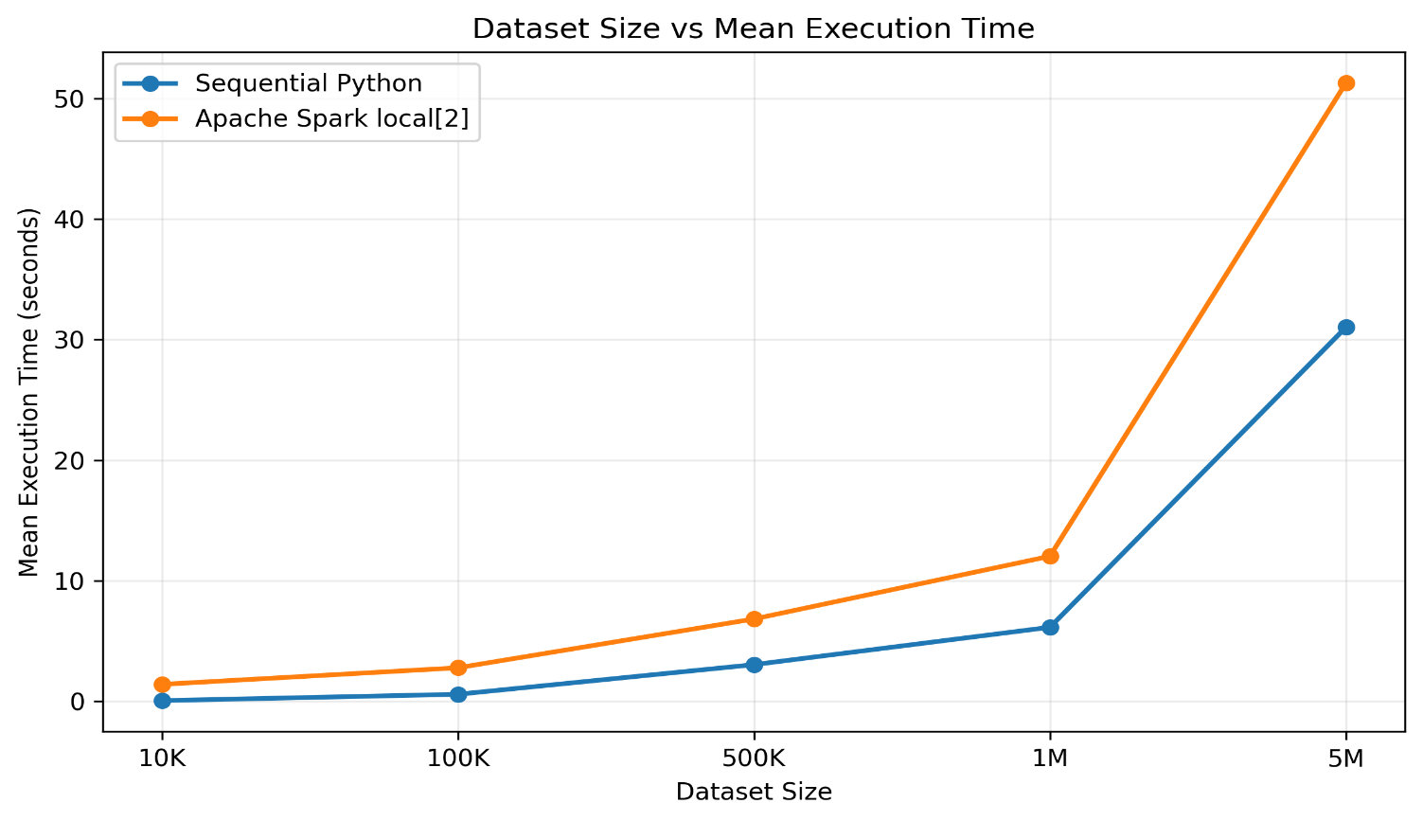
Figure 1. Mean execution time of sequential Python and Apache Spark local[2] across different dataset sizes.
Figure 1 shows that execution time increased for both sequential Python and Apache Spark as the dataset size increased. Sequential Python had lower execution time than Spark local[2] for all tested dataset sizes. However, the relative performance difference became smaller as the workload increased.
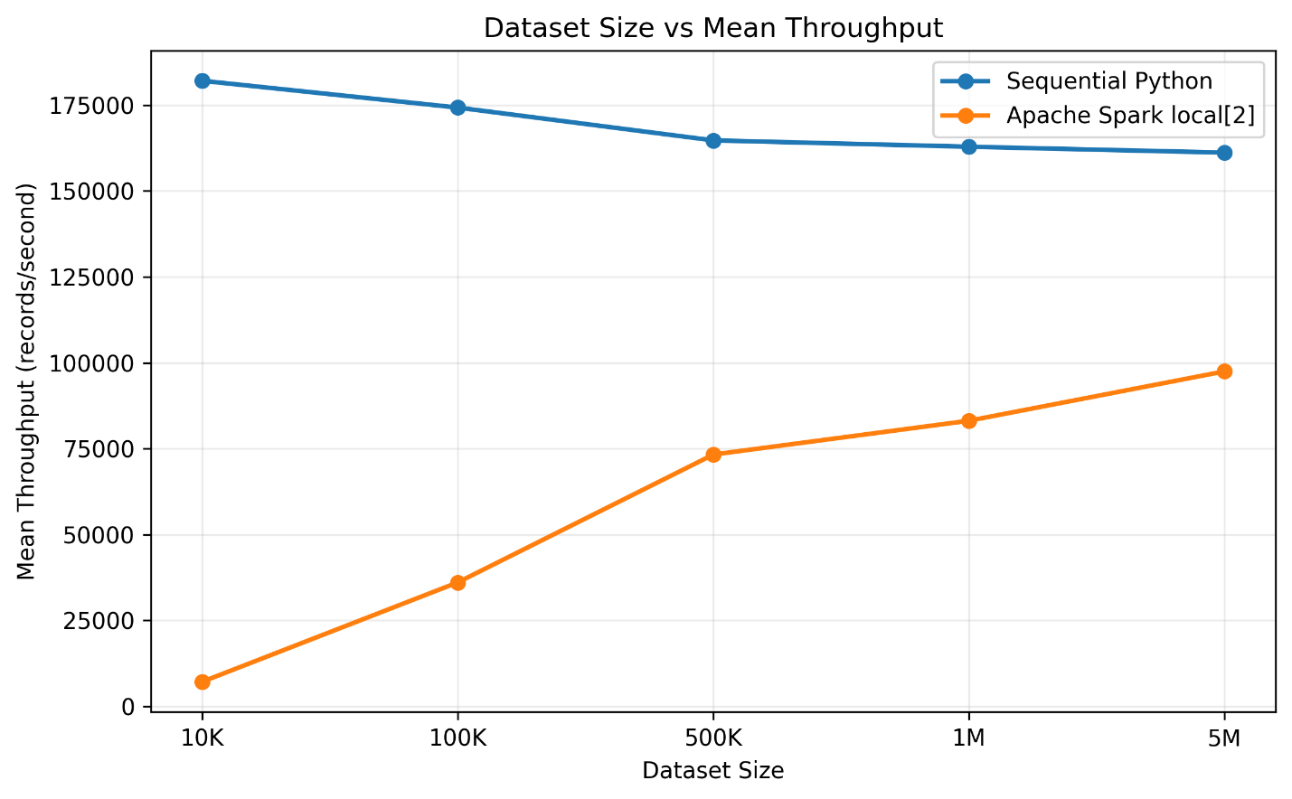
Figure 2. Mean throughput of sequential Python and Apache Spark local[2] across different dataset sizes.
Figure 2 shows the mean throughput of sequential Python and Apache Spark for different dataset sizes. Sequential Python achieved higher throughput for all tested dataset sizes. However, Spark throughput increased substantially as the workload increased, from approximately 7,121 records per second for 10K records to approximately 97,502 records per second for 5 million records. This indicates that Spark utilized its processing capability more effectively as the workload became larger.
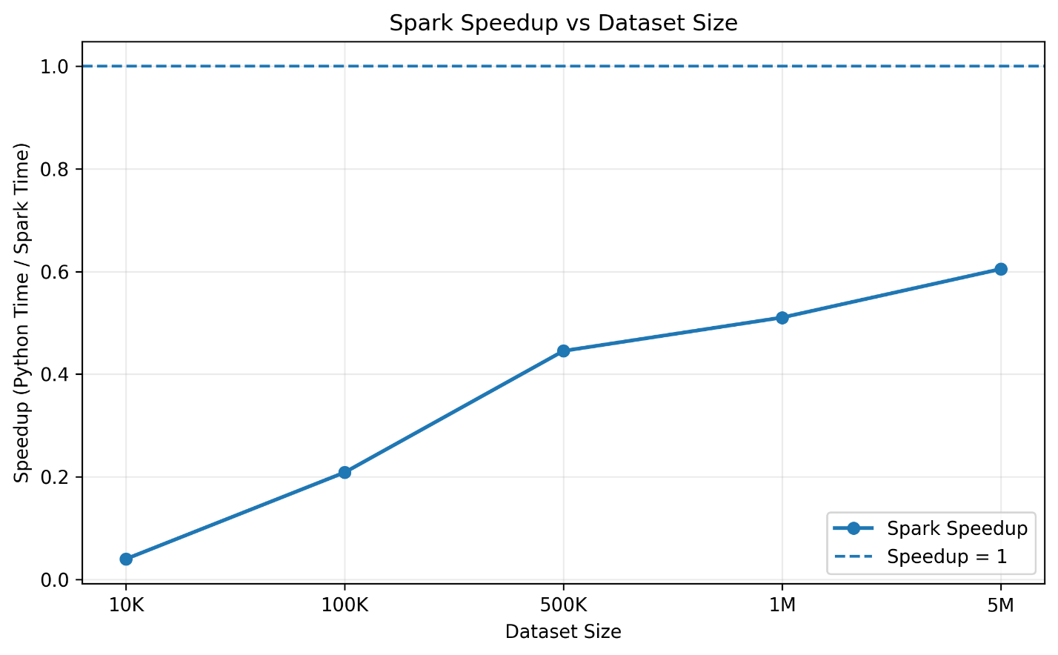
Figure 3. Spark speedup relative to sequential Python across different dataset sizes.
Figure 3 shows that the speedup increased as the dataset size increased, from 0.0399 for 10K records to 0.6049 for 5 million records. The dashed line at speedup = 1 represents the point at which Spark and sequential Python would have equal execution time. All measured values remained below this line, indicating that Spark local[2] did not outperform sequential Python for any of the tested dataset sizes. However, the increasing trend shows that Spark's relative performance improved as the workload became larger.
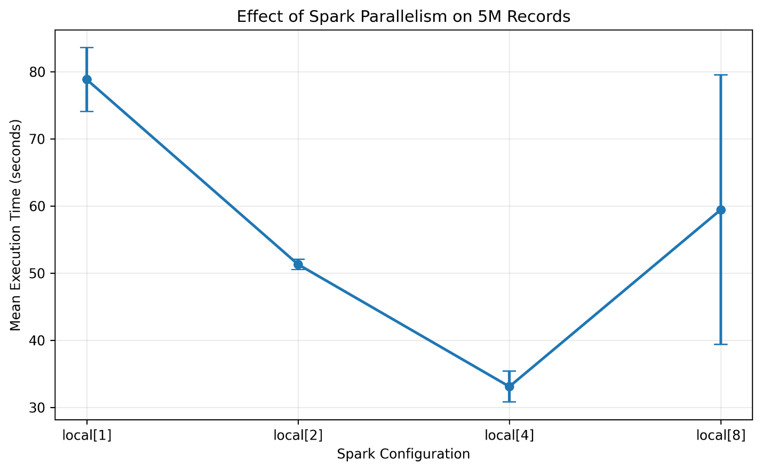
Figure 4. Effect of Spark parallelism on mean execution time for the 5-million-record dataset.
Figure 4 shows that the mean execution time decreased as Spark parallelism increased from local[1] to local[4]. The execution time decreased from approximately 78.83 seconds with local[1] to 33.08 seconds with local[4]. However, local[8] increased the mean execution time to approximately 59.43 seconds and also showed greater variation between runs. Among the tested configurations, local[4] achieved the lowest mean execution time.
6. Discussion
The experimental results demonstrate that dataset size and the level of parallelism have an important effect on the performance of Apache Spark. In the dataset-size experiment, sequential Python achieved lower execution time and higher throughput than Spark local[2] for all tested dataset sizes. The difference was particularly large for smaller datasets. This suggests that, in the tested local environment, Spark's processing overhead had a significant effect when the workload was small.
As the dataset size increased, Spark's relative performance improved. This can be observed from the speedup values, which increased from 0.0399 for 10K records to 0.6049 for 5 million records. Although Spark did not become faster than sequential Python within the tested dataset range, the increasing speedup and throughput indicate that the relative impact of Spark's overhead became smaller as the workload increased.

The parallelism experiment further demonstrates that increasing the number of processing threads does not always result in continuous performance improvement. For the 5-million-record dataset, increasing Spark parallelism from local[1] to local[2] and local[4] reduced the mean execution time from 78.83 seconds to 51.29 seconds and 33.08 seconds, respectively. This shows that the workload benefited from increased parallelism up to local[4] in the tested environment.
When the configuration was increased to local[8], the mean execution time increased to 59.43 seconds, with a relatively high standard deviation of 20.08 seconds. This indicates that the performance was more variable at local[8]. Possible factors may include resource contention, memory-management overhead, garbage collection, input/output activity, or other system activity. However, these factors were not measured directly in this experiment, so the exact cause of the performance reduction cannot be determined from the collected results.
6.1 Answers to Research Questions
RQ1: How does Apache Spark-based log processing perform compared with sequential Python processing as the size of web-server log data increases?
The experimental results show that sequential Python was faster than Apache Spark local[2] for all tested dataset sizes from 10,000 to 5 million records. However, Spark's relative performance improved as the dataset size increased. The Spark speedup increased from 0.0399 at 10K records to 0.6049 at 5 million records, while Spark throughput also increased substantially. Therefore, for the tested single-machine environment, Spark local[2] did not outperform sequential Python, but its relative performance improved with larger workloads.
RQ2: How does changing the level of Spark parallelism affect execution time and throughput?
The parallelism experiment showed that increasing Spark parallelism from local[1] to local[4] reduced execution time and increased throughput for the 5-million-record dataset. Among the tested configurations, local[4] achieved the lowest mean execution time of 33.08 seconds and the highest mean throughput of approximately 151,694 records per second. Increasing parallelism further to local[8] did not provide additional improvement and produced greater variation between runs. Therefore, the results show that increasing parallelism does not necessarily lead to continuous performance improvement.
7. Limitations / Threats to Validity
This study has several limitations that should be considered when interpreting the experimental results. First, Apache Spark was executed in local mode on a single computer rather than on a multi-node cluster. Therefore, the results represent local parallel processing and cannot be directly generalized to the performance of Spark in a production-scale distributed cluster.
Second, the experiments used synthetically generated web-server logs rather than logs collected from a real production web server. Although the synthetic datasets provided a controlled workload for comparing the two implementations, real-world log data may contain more diverse records, distributions, and processing requirements.
Third, the experiments were limited to five dataset sizes ranging from 10,000 to 5 million records. Dataset sizes beyond 5 million records were not evaluated. Therefore, the results cannot be used to determine whether Spark would outperform sequential Python for workloads larger than those tested in this study.
Finally, the experimental results may be influenced by the hardware and software configuration of the test computer. Each experiment was repeated five times and the mean and standard deviation were calculated to account for normal execution-time variation. However, factors such as background system activity and resource availability may still affect the measurements. In addition, the Python and Spark implementations perform the same logical log-processing operations, but their internal execution mechanisms differ. Therefore, the comparison represents the observed performance of the two implementations rather than an identical low-level execution process.
8. Conclusion
This study evaluated the performance of sequential Python and Apache Spark for processing web-server log data across increasing dataset sizes. Synthetic datasets ranging from 10,000 to 5 million records were processed using the same logical operations, including total request counting, status-code analysis, 4xx and 5xx error counting, and URL-wise aggregation. Performance was evaluated using execution time, throughput, speedup, and scalability.
The experimental results showed that sequential Python achieved lower execution time than Spark local[2] for all tested dataset sizes. However, Spark's relative performance improved as the workload increased, with speedup increasing from 0.0399 for 10K records to 0.6049 for 5 million records. The parallelism experiment also showed that increasing Spark parallelism from local[1] to local[4] improved performance, while local[8] did not provide further improvement. Among the tested Spark configurations, local[4] achieved the lowest mean execution time for the 5-million-record dataset.
Overall, the study demonstrates that the performance benefit of parallel processing depends on workload size and the available computing resources. Spark introduces overhead that can have a significant effect on smaller workloads, while increased parallelism can improve performance for larger workloads. Since the experiments were conducted using Spark local mode on a single computer, further experiments on a multi-node Spark cluster are required before generalizing these findings to a fully distributed environment.
9. Future Work
Future work can extend this study by conducting experiments on a multi-node Apache Spark cluster to evaluate true distributed processing across multiple machines. Larger datasets beyond 5 million records can also be tested to investigate performance trends at higher workload sizes. In addition, real-world web-server log datasets can be used to evaluate the approaches under more realistic workload conditions.
Further experiments can investigate Spark optimization techniques such as caching, partition tuning, predefined schemas, and different memory and resource configurations. The experiments can also be repeated on different hardware and cloud-based Spark environments to study how computing resources and deployment environments affect performance.

References
[1] N. Ahmed, A. L. C. Barczak, T. Susnjak, and M. A. Rashid, “A comprehensive performance analysis of Apache Hadoop and Apache Spark for large scale data sets using HiBench,” Journal of Big Data, vol. 7, article 110, 2020, doi: 10.1186/s40537-020-00388-5.
[2] G. Cheng, S. Ying, B. Wang, and Y. Li, “Efficient Performance Prediction for Apache Spark,” Journal of Parallel and Distributed Computing, vol. 149, pp. 40–51, 2021, doi: 10.1016/j.jpdc.2020.10.010.
[3] G. Cheng, S. Ying, and B. Wang, “Tuning configuration of Apache Spark on public clouds by combining multi-objective optimization and performance prediction model,” Journal of Systems and Software, vol. 180, article 111028, 2021, doi: 10.1016/j.jss.2021.111028.
[4] C. Li, Y. Zhang, and Y. Luo, “Intermediate data placement and cache replacement strategy under Spark platform,” Journal of Parallel and Distributed Computing, vol. 163, pp. 114–135, 2022, doi: 10.1016/j.jpdc.2022.01.020.
[5] X. Huang, H. Zhang, and X. Zhai, “A Novel Reinforcement Learning Approach for Spark Configuration Parameter Optimization,” Sensors, vol. 22, no. 15, article 5930, 2022, doi: 10.3390/s22155930.
[6] A. P. Boros, P. Lehotay-Kéry, and A. Kiss, “Performance impact of network security features on log processing with Spark,” Annales Universitatis Scientiarum Budapestinensis de Rolando Eötvös Nominatae, Sectio Computatorica, vol. 55, pp. 19–37, 2023, doi: 10.71352/ac.55.019.
[7] A. Ninan, “Performance Tuning and Optimization of Apache Spark Applications,” International Journal of Computer Trends and Technology, vol. 71, no. 5, pp. 10–14, 2023, doi: 10.14445/22312803/IJCTT-V71I5P103.
[8] P. Sewal, H. S. Rawat, and R. Sharma, “Algorithmic Proficiency in Spark Configuration Tuning: An Empirical Study using Execution Time Metrics across Varied Workloads,” Procedia Computer Science, vol. 235, pp. 2307–2317, 2024, doi: 10.1016/j.procs.2024.04.219.
[9] Q. He, F. Zhang, G. Bian, W. Zhang, and Z. Li, “Research on Performance Optimization of Spark Distributed Computing Platform,” Computers, Materials & Continua, vol. 79, no. 2, pp. 2833–2850, 2024, doi: 10.32604/cmc.2024.046807.
[10] M. Jayanthi, K. Ram Mohan Rao, and V. Sukanya, “Evaluation of Multiple Apache Spark Applications using Kubernetes as a Cluster Manager on Google Cloud,” Procedia Computer Science, vol. 252, pp. 576–582, 2025, doi: 10.1016/j.procs.2025.01.017.
[11] C. Li and X. Wen, “A Survey of Spark Scheduling Strategy Optimization Techniques and Development Trends,” Computers, Materials & Continua, vol. 83, no. 3, pp. 3843–3875, 2025, doi: 10.32604/cmc.2025.063047.
[12] H. Yoon and Y. D. Chung, “Empirical Evaluation of Acquisition Functions for Bayesian Optimization-Based Configuration Tuning of Apache Spark Applications,” IEICE Transactions on Information and Systems, vol. E108-D, no. 10, pp. 1246–1249, 2025, doi: 10.1587/transinf.2024EDL8071.
[13] I. Mavridis and H. D. Karatza, “Performance evaluation of cloud-based log file analysis with Apache Hadoop and Apache Spark,” Journal of Systems and Software, vol. 125, pp. 133–151, 2017, doi: 10.1016/j.jss.2016.11.037.
[14] K. Aziz, D. Zaidouni, and M. Bellafkih, “Leveraging resource management for efficient performance of Apache Spark,” Journal of Big Data, vol. 6, article 78, 2019, doi: 10.1186/s40537-019-0240-1.
[15] H. Al-Sayeh, S. Hagedorn, and K.-U. Sattler, “A gray-box modeling methodology for runtime prediction of Apache Spark jobs,” Distributed and Parallel Databases, vol. 38, pp. 819–839, 2020, doi: 10.1007/s10619-020-07286-y.
[16] A. Karami and M. Amirhosseini, “WASPO: Workload-Aware Spark Performance Optimization Using NSGA-II,” in Cognitive Models and Artificial Intelligence Conference, 2025, doi: 10.1109/AICCONF64766.2025.11064004.
[17] Y. Chen, M. A. Hoque, P. Xu, J. Lu, and S. Tarkoma, “SimCost: cost-effective resource provision prediction and recommendation for Spark workloads,” Distributed and Parallel Databases, vol. 42, pp. 73–102, 2024, doi: 10.1007/s10619-023-07436-y.
[18] N. M. Mirza, A. Ali, N. S. Musa, and M. K. Ishak, “Enhancing Task Management in Apache Spark Through Energy-Efficient Data Segregation and Time-Based Scheduling,” IEEE Access, vol. 12, pp. 105080–105095, 2024, doi: 10.1109/ACCESS.2024.3435705.
[19] S. Jeon and D. Park, “Performance Optimization of Apache Spark for Real-Time Analysis of Massive Log Data,” Journal of Platform Technology, vol. 13, no. 4, pp. 72–91, 2025, doi: 10.23023/JPT.2025.13.4.072.
[20] Y. Li, Y. Jiang, J. Gu, M. Lu, M. Yu, E. M. Armstrong, T. Huang, D. Moroni, L. J. McGibbney, G. Frank, and C. Yang, “A Cloud-Based Framework for Large-Scale Log Mining through Apache Spark and Elasticsearch,” Applied Sciences, vol. 9, no. 6, article 1114, 2019, doi: 10.3390/app9061114.

